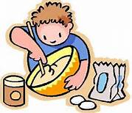

Dear Reader:
Our third grade class spent five weeks learning about different family cultures around the world. Many of the stories we spent time reading explained how families share their heritage with each other and keep traditions alive. Food was a reoccurring theme in these stories and our third graders were able to share recipes that are special to their families and/or family history. We hope you enjoy trying some of the treats we have collected in this book and you might just add some great family traditions along the way!
Happy Cooking!
Sadie, Lucy, Lokie, Trevor, Gabriel, Jolie, Raylee, Hanna, Bruce, Justice, Christopher, Levi, Ashton, Emily, Melissa, Lauren, Tyler, Connor T., Connor V., Breylon, Jeremy, Will, and Mrs. Strycker

